Tone: Ancient
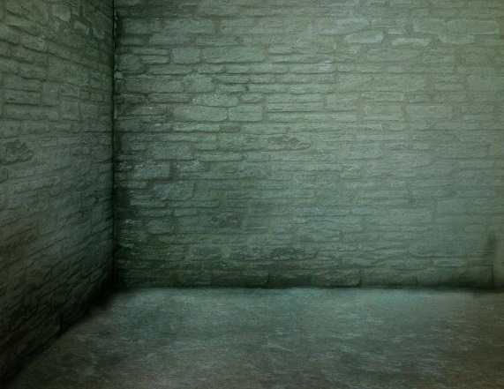
Tolling in the silence the minutes of the earth and the hours and the days of it and the years without cease, until they stood in a great stone room where lay a black and ancient lake.
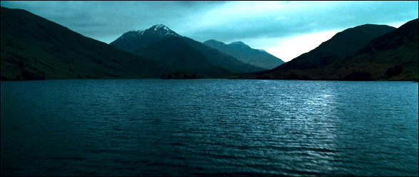

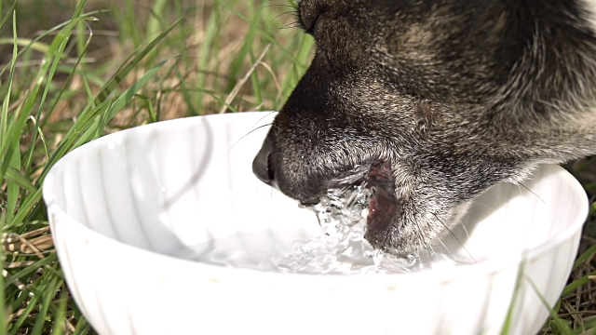
And on the far shore a creature that raised its dripping mouth
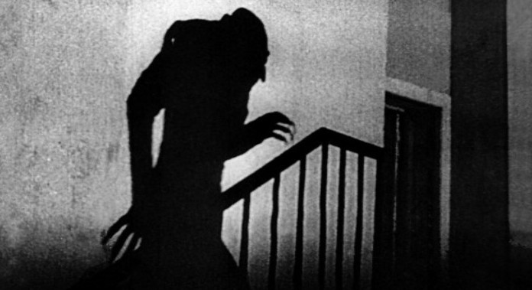
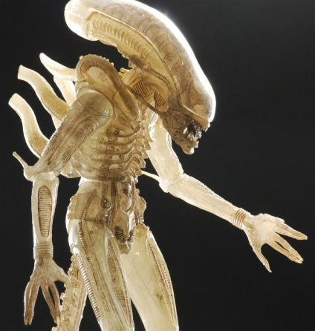
from the rimstone pool and stared into the light with eyes dead white and sightless as the eggs of spiders. It swung its head low over the water as if to take the scent of what it could not see. Crouching there pale and naked and translucent, its alabaster bones cast upon shadow on the rocks behind it.

Its bowels, its beating heart. The brain that pulsed in a dull glass bell. It swung its head from side to side and then gave a low moan and turned and lurched away and loped soundlessly into the dark.

