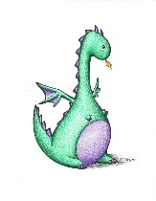
Fantasy Genre Analysis
Read three flash fiction fantasy stories and answer the following questions:
Genre Analysis
- What elements/techniques are unique to the fantasy genre?

- What elements/techniques unique to the fantasy genre were shared by all 3 stories?

- How formal/informal is the language? Give examples with your explanation.

- What specialized vocabulary is used? Give examples with your explanation.

- What other language features do you notice?

Story Cohesion Analysis (pick your favorite of the three stories and apply the following questions)
- Give an example where one of the stories “shows” instead of “tells”

- Why is it more compelling to “show” instead of “tell”?

- Where did you see repetition? Give an example from the text.

- What effect did this repetition have on the story?

- Where did you see description? Give an example.

- Where did you see imagery? Give an example.

- Where did you see symbolism? Give an example.

- What effect did these descriptive elements have on the effectiveness of the story?

- Describe which story was more “balanced” – multiple elements (“showing not telling”, “repition”, “description”, “imagery”, “symbolism”) were present but none overwhelmed the story.

- Describe how to balance multiple techniques to make a story “come together”:

